**Abstract**

**Table of Contents**

**List of Figures**

**Chapter**

1. **Preamble**
   1. **Introduction**
   2. **Problem Statement**
2. **System Design**
3. **SRS**
4. **Implementation / Methodology**
5. **Software Testing**
6. **Code**
7. **Conclusion**
8. **References**

**Abstract**

Normally Users are not aware about all the treatment or symptoms regarding the particular disease. For small problem user have to go personally to the hospital for check-up which is more time consuming. Also handling the telephonic calls for the complaints is quite hectic. Such a problem can be solved by using medical Chatbot by giving proper guidance regarding healthy living.

**List of Figures**

**Chapter**

1. **Preamble**
   1. **Introduction**

The main purpose of the scheme is to build the language gap between the user and health providers by giving immediate replies to the Questions asked by the user. Today’s people are more likely addicted to internet but they are not concern about their personal health. They avoid to go in hospital for small problem which may become a major disease in future. Establishing question answer forums is becoming a simple way to answer those queries rather than browsing through the list of potentially relevant document from the web. Many of the existing systems have some limitation such as There is no instant response given to the patients, they have to wait for expert’s acknowledgement for a long time. Some of the processes may charge amount to perform live chat or telephony communication with doctors online.

This system allows computer to communication between human to computer by using AI. An AI-based chatbot is a software application that is primarily used for initiating human conversations and providing the solution for queries provided by the user. As new businesses are flourishing with the use of the latest technology, the use of chatbots in the daily life of consumers is increasing rapidly. They can be used for various purposes like customer servicing, request routing or information fetching. One such application of chatbots is in the healthcare sector. The proposed solution focuses on a healthcare chatbot application that analyses the user’s symptoms through a conversation with the user and maps these symptoms to the available dataset. The system can converse with the user via text or speech. The user can choose the language he wishes to communicate in. The input from the user is taken as symptoms. The symptoms are then passed to a Machine Learning (ML) algorithm that has been trained to diagnose diseases based on symptoms.

* 1. **Problem statement**

Healthcare is very important to lead a good life. However, it is very difficult to obtain a consultation with a doctor for every health problem. The idea is to create a medical chatbot using Artificial Intelligence that can diagnose the disease and provide basic details about the disease before consulting a doctor. This will help to reduce healthcare costs and improve accessibility to medical knowledge through medical chatbots. Chatbots are computer programs that use natural language to interact with users. The score will be obtained for each sentence from the given input sentence and more similar sentences will be obtained for the query given. Modern machine learning solutions will help us to avoid these and others problems.

1. **System Design**

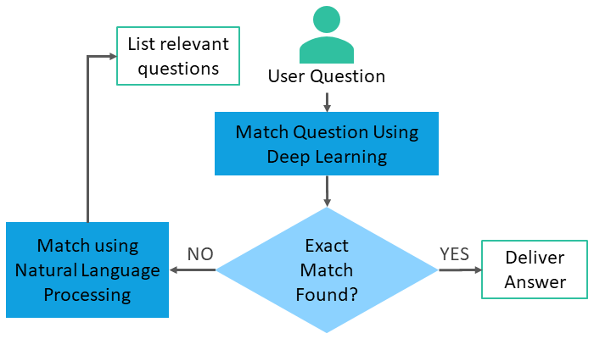

**3. SRS**

* 1. **Functional Requirements:**

Hardware Requirements

- Pentium Processor IV or Higher

- Min 10 GB HDD

- RAM 512 MB or Higher

- 2.4 GHz or faster Processor

Software Requirements

* Windows Vista onwards, Linux, Mac OS
* In the case of building the Project from the source
  + Python Compiler
  + Sklearn Learn
  + Pandas
  + Numpy
  + Flask

**3.2 Non-Functional Requirements:**

Software Quality Attributes

* Robustness
* Reliability
* Better learning methods
* Acquiring good accuracy results

1. **Implementation / Methodology**

**Data collection**

The datasets are saved and converted into a CSV file that can be read by the sentiment analysis program. The dataset will be constantly upgraded and replaced with data from requested keywords. The keywords are then processed into the sentiment analyser.

The data sets consist of

* Name of the consulting doctor and information about them
* Name of the different types of diseases
* Data processing

The data collected is saved and processed into a CSV file that holds text data and numerical data for the specific. The CSV file is set into the script of the sentiment analyser that’ll prepare the output data in two formats.

**Experiment setup**

We use a different kind of methods combined with different scoring and weighting models. It provides the output based on the user’s input in the “Yes” or “No” format. Based on this the user gets the output of the disease they may have and also the doctor’s information to whom they can consult.

1. **Software Testing**

The research in this thesis focuses on predicting the probable disease that the user may have based on their Inputs which consists of the simple “Yes” or “No” options. If pressed on the option “Yes” to a particular question, then the result to that particular query is provided to the user else pressing on “No” option will proceed to ask the user the next symptom if he/she has.

1. **Code**

https://github.com/pranalikedar/HEALTHCARE-CHATBOT-

1. **Conclusion**

The result of the previous Health Care issues was addressed manually and used to consume more time even for simple problems. The proposed system is an efficient, cheap, easy and a quick way to help patients to have a one-to-one conversation with the Chatbot that helps and assists them to take care of their health effectively. With the chat bot help of Chat bot users can post their symptoms and get the solutions from the bot. The system can be accessed from anywhere and at any time conveniently.

1. **References**

[1] Flora Amato, Stefano Marrone, “Chatbots meet eHealth: automat zing healthcare”, proceeding of diet, May-2018

[2] BenildaEleonor V. Comendador, “Pharmabot: A pediatric generic Medicine consultant Chatbot”, proceeding of the JACE, April 2015.

[3] Kowatsch, T., M. Nißen, C.-H. I. Shih, D. Rüegger, D. Volland, A. Filler, F. Künzler, F. Barata, D. Büchter, B. Brogle, et al. (2017). Text-based healthcare chatbots supporting patient and health professional teams: preliminary results of a randomized controlled trial on childhood obesity.

[4] Lin Ni(B), Chenhao Lu, Niu Liu, and Jiamou Liu,” MANDY: Towards a Smart Primary Care Chatbot Application”, SPRINGER,2017.

[5] Mrs. Rashmi Dharwadkar, Dr.Mrs. Neeta A. Deshpande "A Medical ChatBot". International Journal of Computer Trends and Technology (IJCTT) V60(1):41-45 June 2018. ISSN:2231-2803.